
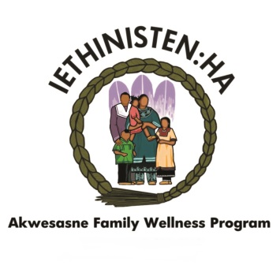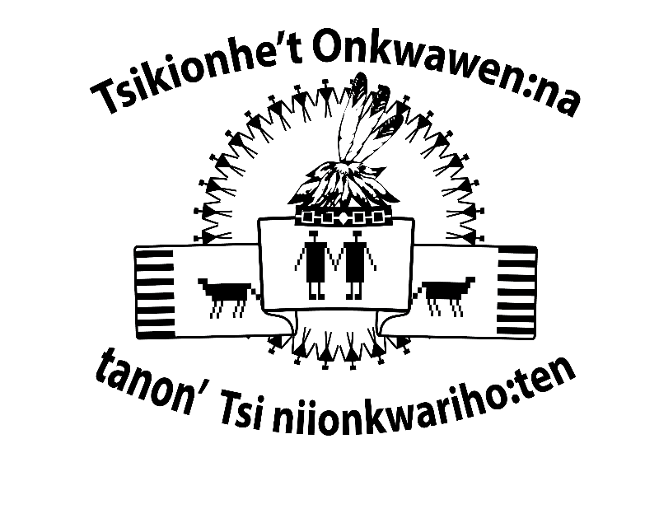
Hosted by: Akwesasne Community Justice Program

Sponsored by: Iethinisten:ha Family Wellness Program
& Independent First Nations

Tsikionhet Onkwawen:na tanon Tsiniionkwariho:ten
Youth Cultural Camp

Registration Form

Open to Ages – Thirteen (13) to Eighteen (18)
GENERAL INFORMATION
Registrant’s Full Name: ____________________________________________________Birth Date: ___________________________
Parent/Guardian’s Name: _______________________________________________________________Age: ________________________
Address: __________________________________________________________________________________________
Day Phone: _________________________________ Cell Phone: _________________________________
EMERGENCY CONTACT INFORMATION
Full Name: ___________________________________________________________________________________________
Relationship to Registrant: ________________________________ Phone Number: ______________________________________
Full Name: ___________________________________________________________________________________________
Relationship to Registrant:_________________________________ Phone Number: ______________________________________
MEDICAL INFORMATION
Please describe any medical condition or special needs the staff should be aware of regarding your child. Please include any allergies, dietary restrictions, etc.
_________________________________________________________________________________________________________________________
Will your child be using any medications during camp hours? __________________________________________________
If so, please list name of medication: _______________________________________________________________________________
Please include written instructions for medication and deliver directly to a camp staff member.
Family Doctor: _____________________________________________________________________________________
Health Card Number: ______________________________________________________________________________
DISCLAIMER
Note: by initialing below, you acknowledge that you have read and agree to each item.
Release Statement:
I hereby give permission for my child to attend Youth Cultural Camp. I acknowledge that there are risks associated with the camp and related activities in the outdoor setting. I hereby affirm that my child is in good health and physically capable of performing the required activities. I hereby release Mohawk Council of Akwesasne, its agents and employees from all claim of liability for any damages or injuries which may be sustained while my child is at Thompson Island or Fishing on the St. Lawrence River.
Initial: ______________
Authorization of Treatment:
I hereby give my permission to the medical personnel selected by the camp director to order necessary treatment for my child. In the event I cannot be reached in an emergency, I hereby give permission to the physician to secure and administer treatment for my child named above.
Initial: _____________
Photo Release:
I hereby give my permission for my child’s picture to be used for publications or video programs.
Initial: _______________
Water Activities:
I understand that the camp includes activities in or near water. I give my permission for my child to participate in all water activities include in the camp.
Initial: _______________
Travel:
I give permission for my child to travel to and from Thompson Island via boat. The boat will be operated by licensed MCA marine operators. I understand there are risks associated with traveling by boat and that my child will be provided with a life jacket and informed of the proper safety protocol.
Initial: ________________
Release of Minors:
In addition to names already listed on this application, my child may be released to the following individual(s):
Name: _____________________________________________ Phone: _______________________________________
Name: _____________________________________________ Phone: _______________________________________
Parent/Guardian Signature: _______________________________________________________________ Date: _____________________

CODE OF CONDUCT
Parent/Guardian: Please review the following information with camp registrant and indicate that you both understand and agree to the rules by signing at the bottom of the page.
- Registrant will follow the directions of the staff.
- Registrant will treat everyone with respect: teasing, put-downs, pranks and name-calling will not be tolerated.
- Registrants will treat our camp property with respect by refraining from littering or abusing the property or equipment.
- Registrants may not possess or use any form of tobacco product, controlled substance, illegal substance or alcoholic beverage.
- Registrants will participate in all scheduled activities and maintain positive attitude.
- Registrants will not carry cell phones, musical devices or electronics.
DISCIPLINARY POLICY
The Youth Cultural Camp is meant to be a fun, educational and traditional activity. For the benefit of all youth, it is important that participants behave appropriately and respectfully within the camp. If it becomes necessary to take disciplinary action against a student, the steps that will be followed are outlined below:
1st incident: The youth will receive a verbal warning and an explanation as to why the behavior is inappropriate (whenever possible, this will be done in a one-on-one setting removed from other registrants).
2nd incident: Staff will determine an appropriate consequence for the registrant’s actions. The registrant’s parent/guardian will be notified of their behavior upon pick up.
3rd incident: The youth will be excused from camp for the remainder of the week.
I have read and agree to follow the Youth Cultural Camp rules.
Registrant signature: ______________________________________________________________________________________________
I have reviewed the Youth Cultural Camp rules and consequences with my camp registrant
Parent/Guardian signature: ______________________________________________________________________________________
Witness: _____________________________________________________________________________________________________________
CLOTHING SIZE
Please indicate the size and also if it is YOUTH or ADULT
T-Shirt Size: ____________________ Y or A
Sweatshirt Size: ____________________ Y or A

WORKSHOP SELECTION
Please indicate if you would be interested in going fishing at 7:00 am to 9:45 am Yes ______ No ______
What days: Tuesday _______ Wednesday ________ Thursday _________

All registrations are due on Friday August 3, 2018 at 4:00 pm to the Akwesasne Community Justice Program

PARENTS AND PARTICIPANTS KEEP

Please keep in mind to bring the following items daily:
- Sneakers/socks for walks through the trails
- Swimming apparel and a towel
- Sun block, sunglasses, hat
- Bug spray
- Extra clothes
- Any other items you think you may need for a day out on the Island.
Please bring the following if you plan on staying overnight on Wednesday August 15th and Thursday August 16th , 2018
- Pajamas
- Bath towel
- Wash cloth
- Flash light
- Pillow (optional)
- Toothbrush and toothpaste
- Soap
- Comb or brush
- Any additional items you may need for your stay at the Island
Should you require additional information please contact Erin Seymour at 613-575-5000, Ext. 2416

