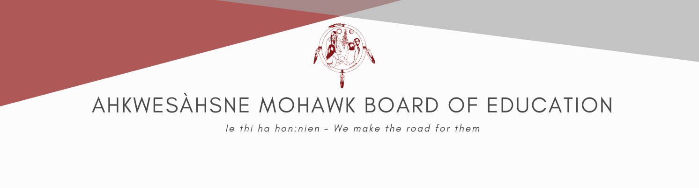
JOB POSTING
ASSOCIATE PRINCIPAL
Term Position

Salary: Pay Band 11 $98,612.80 - $145,975.40

The Ahkwesahsne Mohawk Board of Education (AMBE) was created in 1985 by the Mohawk Council of Akwesasne (MCA). AMBE is responsible for providing educational and Child Care services to the Akwesasne Mohawk Community, including; 3 Child Care Centers and 3 Schools that offer K4 to Grade 8 education; coordination of secondary education service in partnership with local school boards; adult education services; and post-secondary assistance. The Akwesasne Mohawk Community includes about 13,000 Peoples, and borders on the Canadian Provinces of Ontario and Quebec and the American State of New York.

Position Summary:
Under the supervision of and in close consultation with the School Principal, the Associate Principal provides leadership in developing and maintaining rigorous educational programs that optimize available human and material resources and results in the effective operation of the school. The primary task of the Associate Principal is to assist the School Principal in the overall administrative leadership of the school. Specifically, the Associate Principal has a major role in development of plans for students’ academic and social/behavioral success. The Associate Principal is a pedagogical role model and coach who organize teacher training opportunities that foster a positive school culture.

Qualifications:
- Bachelor's Degree in Education;
- 5 years’ of teaching experience, or equivalent
- 3 years’ of leadership experience
- Knowledge of training in SFA and other educational programs used in AMBE schools.

Key Competencies:
The successful candidate will demonstrate the AMBE key values of: integrity, equity and accountability with a focus on:
- Leadership: Positively influencing people and events
- Relationship Building: Developing and maintaining constructive relationships
- Communication: Clearly conveying and receiving messages
- Results Orientation: Knowing what results are important, focusing resources to achieve them
- Strategic Thinking: Taking a broad, long term view, assessing options, and implications
- Planning: Setting clear outcomes and indicators of success
- Cultural Awareness: Understanding of, and sensitivity to, the distinct Akwesasne Mohawk community, culture and language
All interested individuals must submit a letter of interest, resume and copies of certificates/diploma no later than 2:00 pm on January 30, 2026 to;
Lynn Roundpoint, HR Generalist/Labor Relations
Ahkwesahsne Mohawk Board of Education
169 International Rd Akwesasne, ON K6H 0G5 or
email : lynn.roundpoint@ambe.ca

Applicants must clearly outline that they meet the qualification requirements on their resume
- A criminal records check is MANDATORY
- Native Preference in hiring
- Applicants MUST have a Canadian Social Insurance Number
- Applicants MUST provide proof of COVID-19 Vaccinations
- ONLY THOSE SELECTED FOR AN INTERVIEW WILL BE CONTACTED

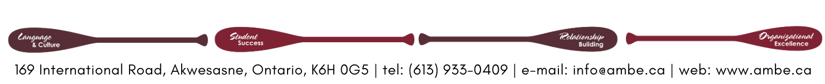
All AMBE employees are required to be eligible to work in Canada,
and have a valid passport to facilitate daily border crossing.

